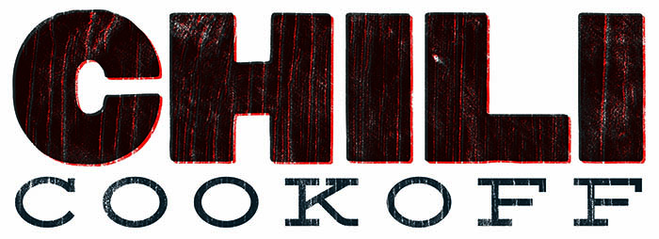

& BINGO Night

Join us **Friday, February 9th**

**At the Riverside VFW from 5:30-8:00pm**

*For the 2nd annual Chili Cook-off and Bingo**games*

*This year’s proceeds will go to help fund the Highland music trip to NYC*

Cost to Enter your Chili- $5

*(Entries show up at 5:00, tasting/judging is from 5:30-7:00)*

1st, 2nd and 3rd place will receive a prize

Cost to vote- $1 per Ballot

Cost to eat- Free Will Donation

Meal will include bowl of chili, sides and desert

Drinks may be purchased from the VFW that evening.

Bingo will begin at 6:00pm

Bingo cards are 4/$1

