First Annual
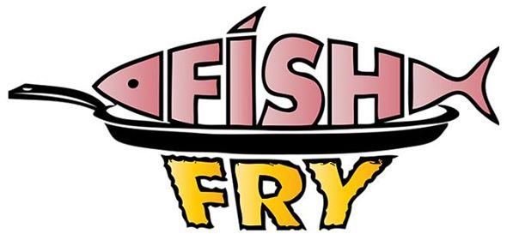

Friday, October 6, 2017
5:00 – 8:00 pm
VFW Post 6414 - Riverside, IA

Fish, French Fries,
Potato Salad, Cole Slaw,
Baked Beans, Corn Bread,
Dessert

Silent Auction for Baskets & Student Work Time

Free Will Donation

Raising funds for Highland music student trips

Next trip to New York City in April 2018

Sponsored by Highland music student’s parents and community businesses.

