WANTED:
Donated Gently Worn, Used & New Shoes

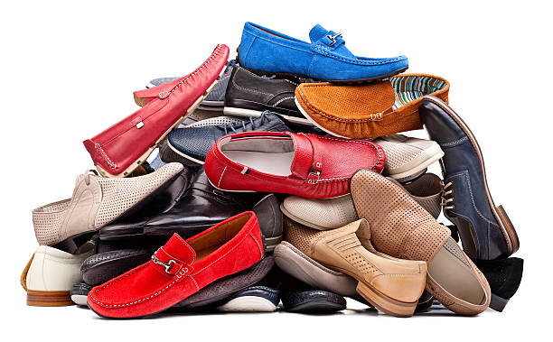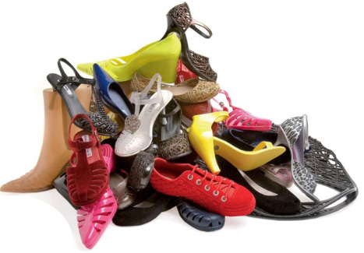

Help us raise funds to offset the cost of the
Highland Band & Choir Students’ trip to
New York City in April 2018

Donate your gently worn*, used and new shoes
(*soles intact, laces present, clean, dry & no holes)

This includes pairs of flip-flops, sandals, athletic shoes, boots,
pumps, cleats, flats, dress shoes, slippers, etc.

The only pairs not accepted are ski boots & any type of skates.

Our Goal: 2500 pairs
By December 15, 2017

Don’t forget to ask friends, family, neighbors and
co-workers to donate too!

Collected shoes are used to support micro-enterprise vendors
(small businesses operated by one person or family & friends)
in developing nations.

Watch for drop off sites at both Highland Elementary and Highland Highschool
For more information check our Facebook page at Parents of Highland Band and Choir Students

