HUSKY Tribute
NEWSPAPER

When we started our fifth grade year we noticed a lot of new and exciting things happening to our Elementary school!

Highland Elementary  Student Council  The first exciting thing we would like to talk about is our 5th grade student council. Our student council is made up of ten fifth graders that will rotate throughout the 2018-2019 school year. On our student council is a president, vice-president, secretary, treasurer, historian, newspaper journalist and yearbook staff. During their time on the student council they will be in charge of many events as well as help with decision making. Student Council has been busy helping with the planning of Homecoming and the homecoming float! | 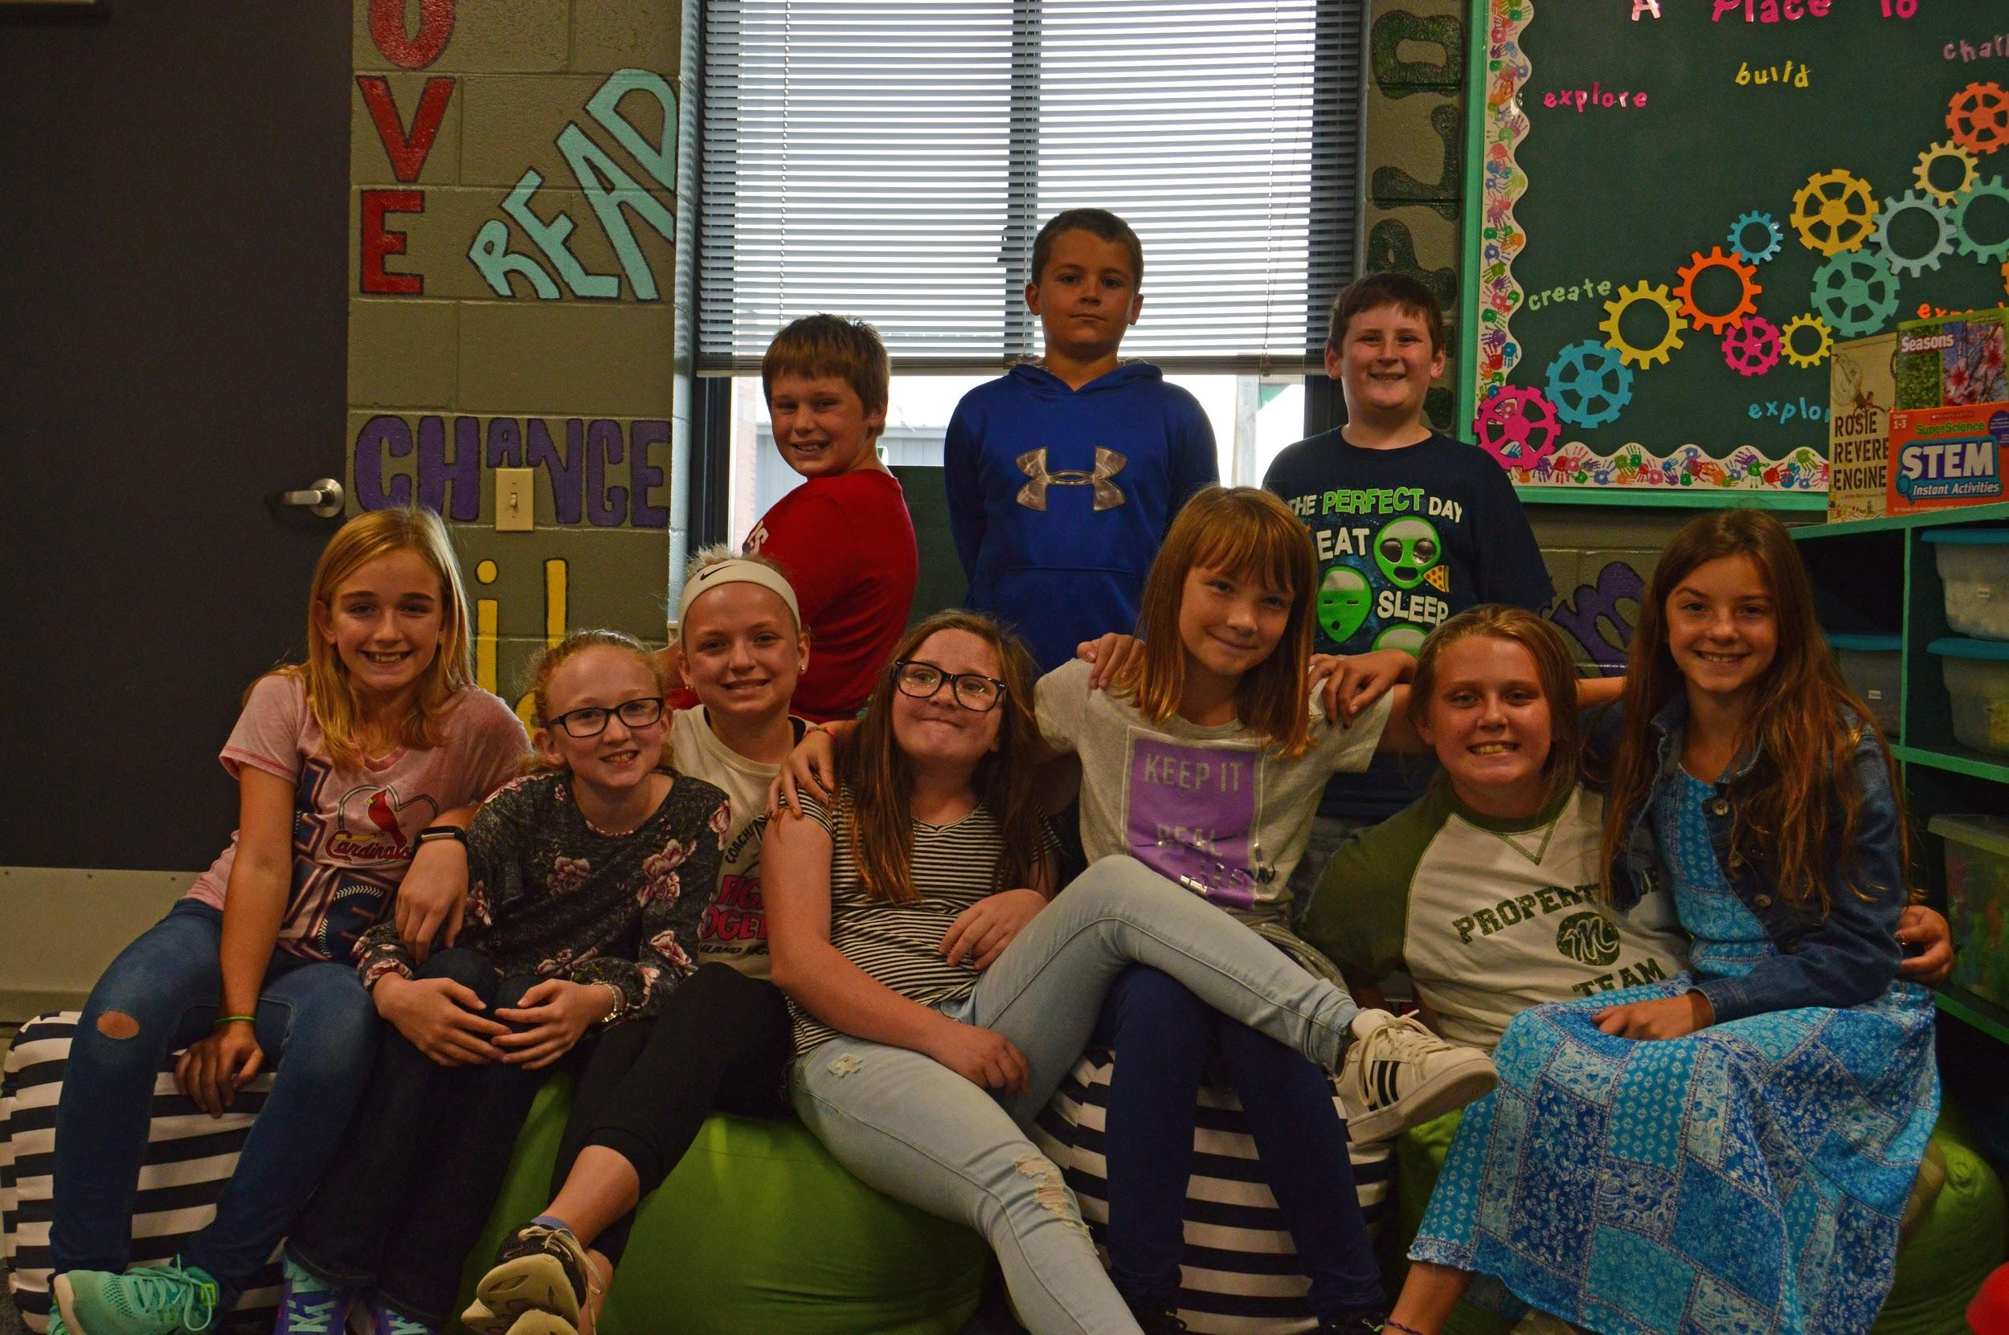  Front row: Adisyn Prottsman, Emma Smart, Brena Hazelett, Emily Herrig, Siena Stanerson, Hailey Plank, Erika Thomann. Back row: Keaton VanSchoyck, Bryce Hazelett, Brayden Zywiec
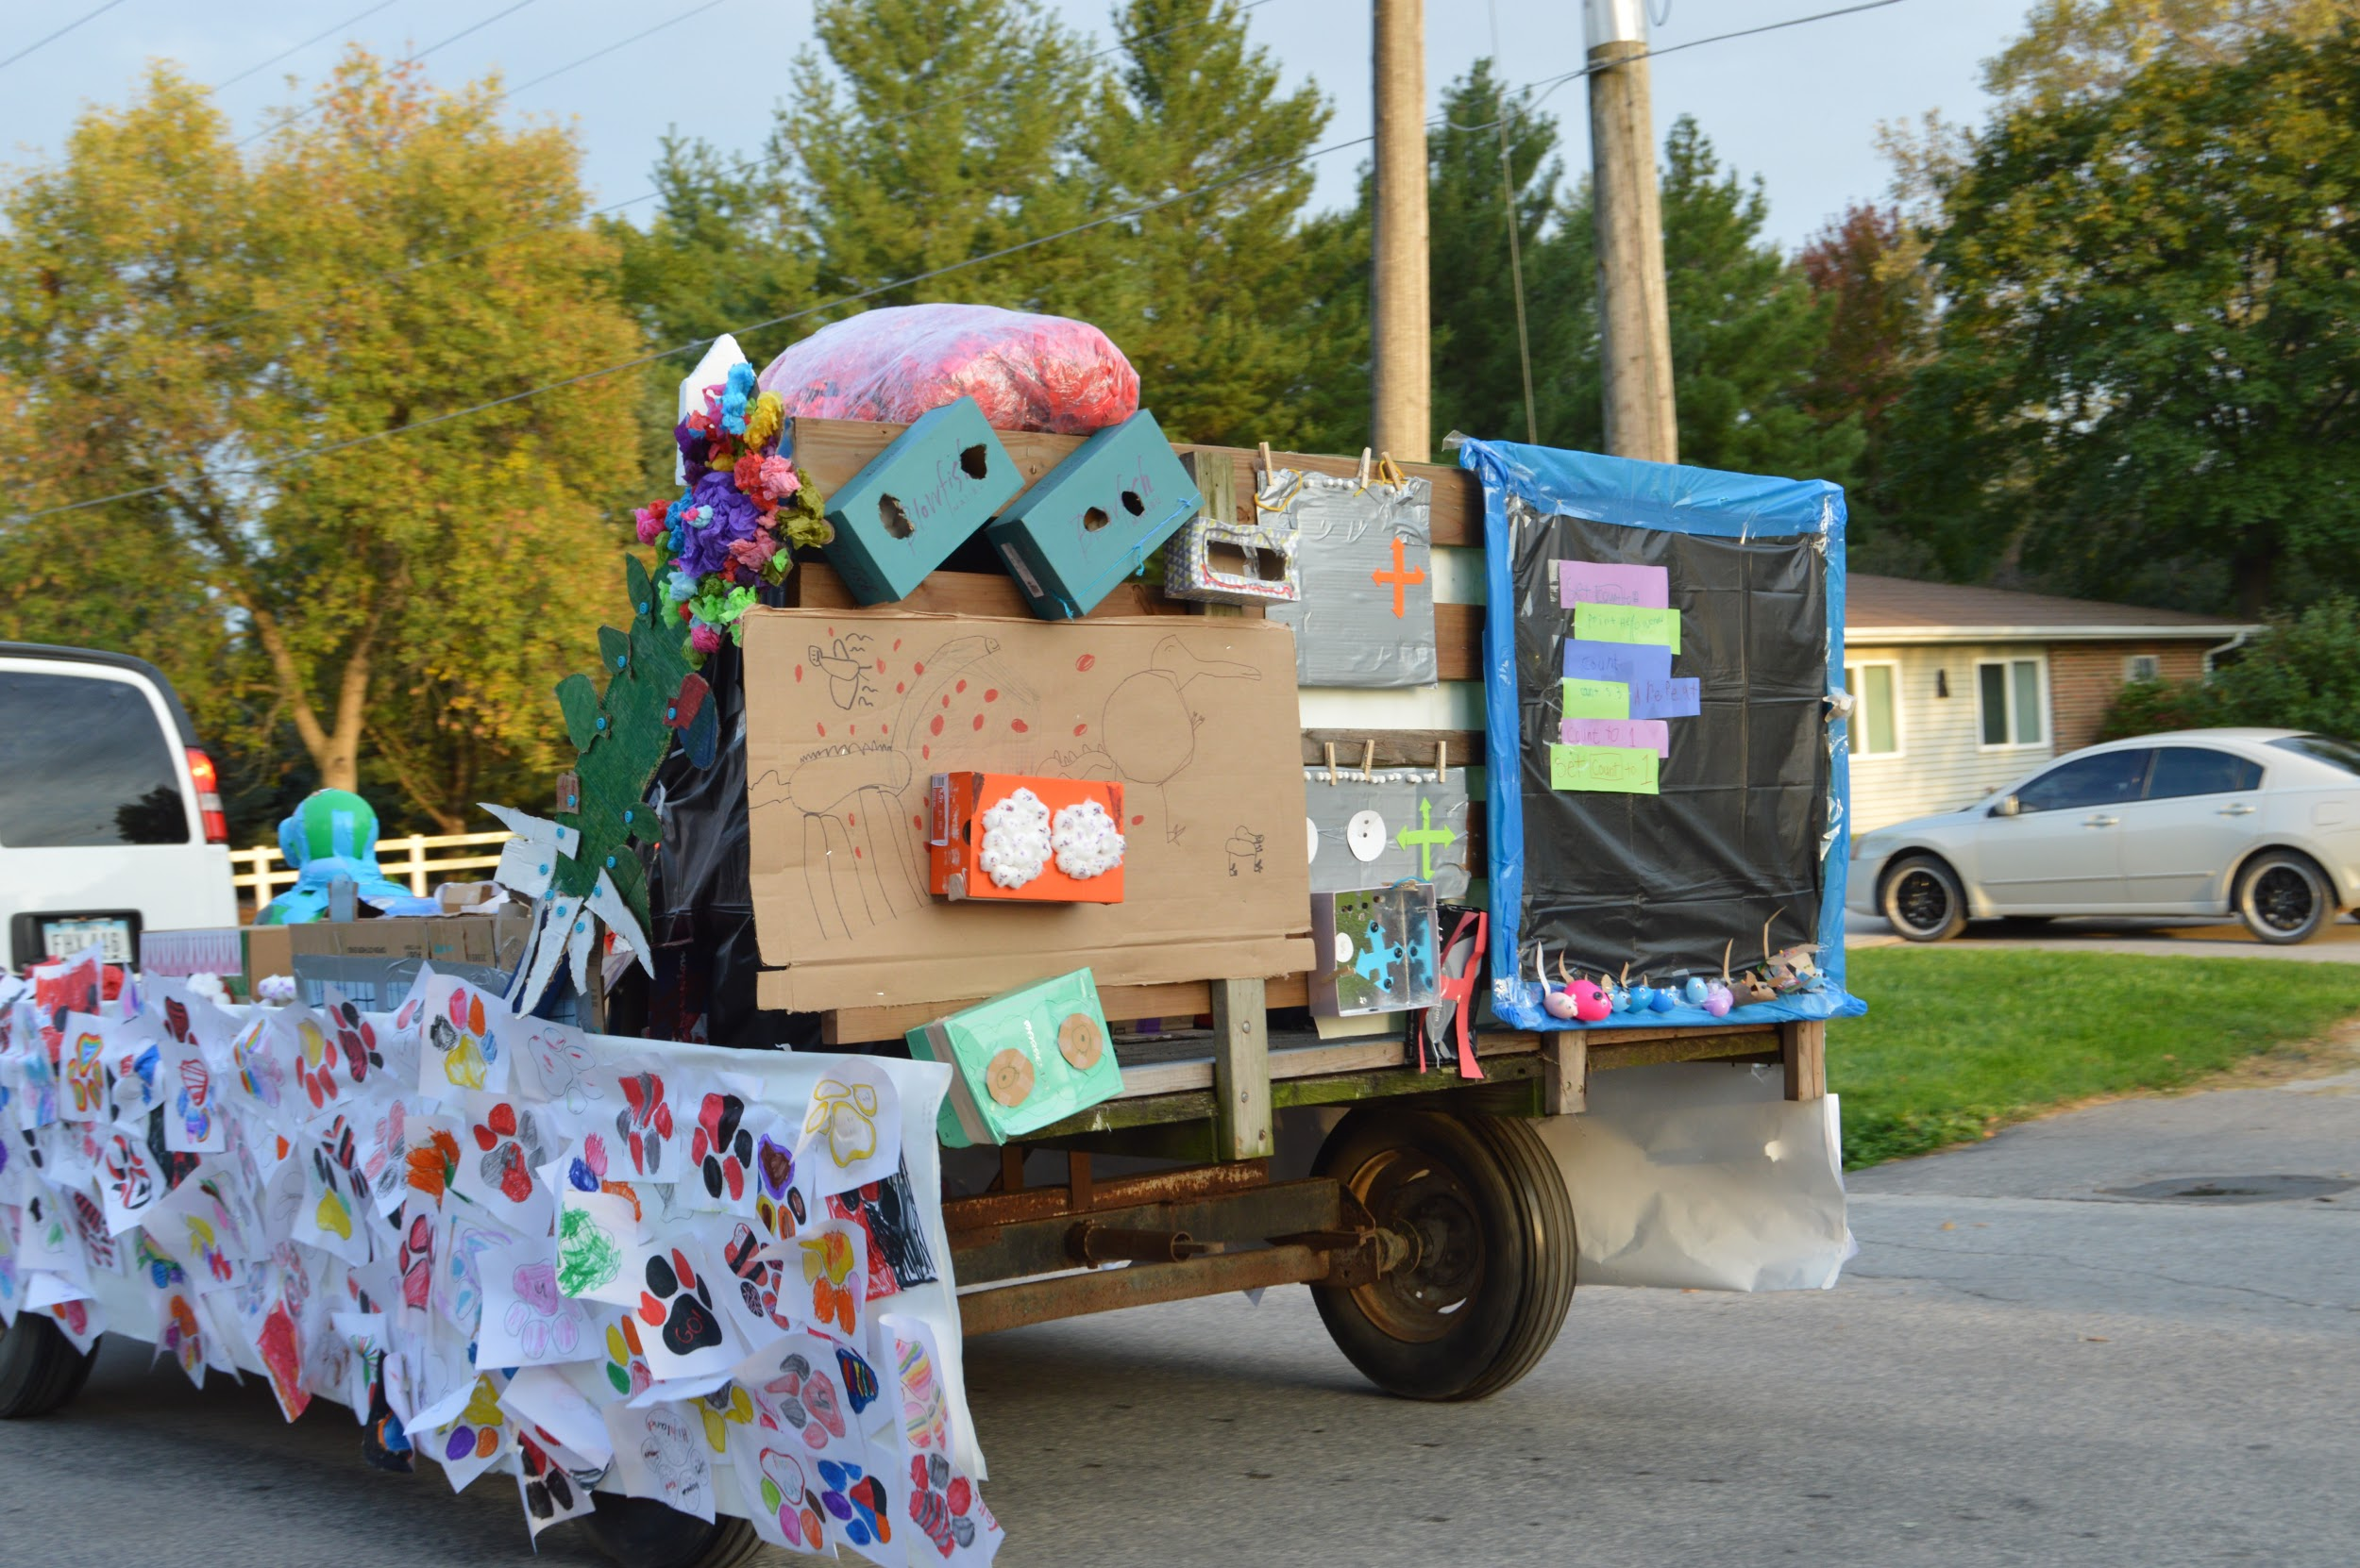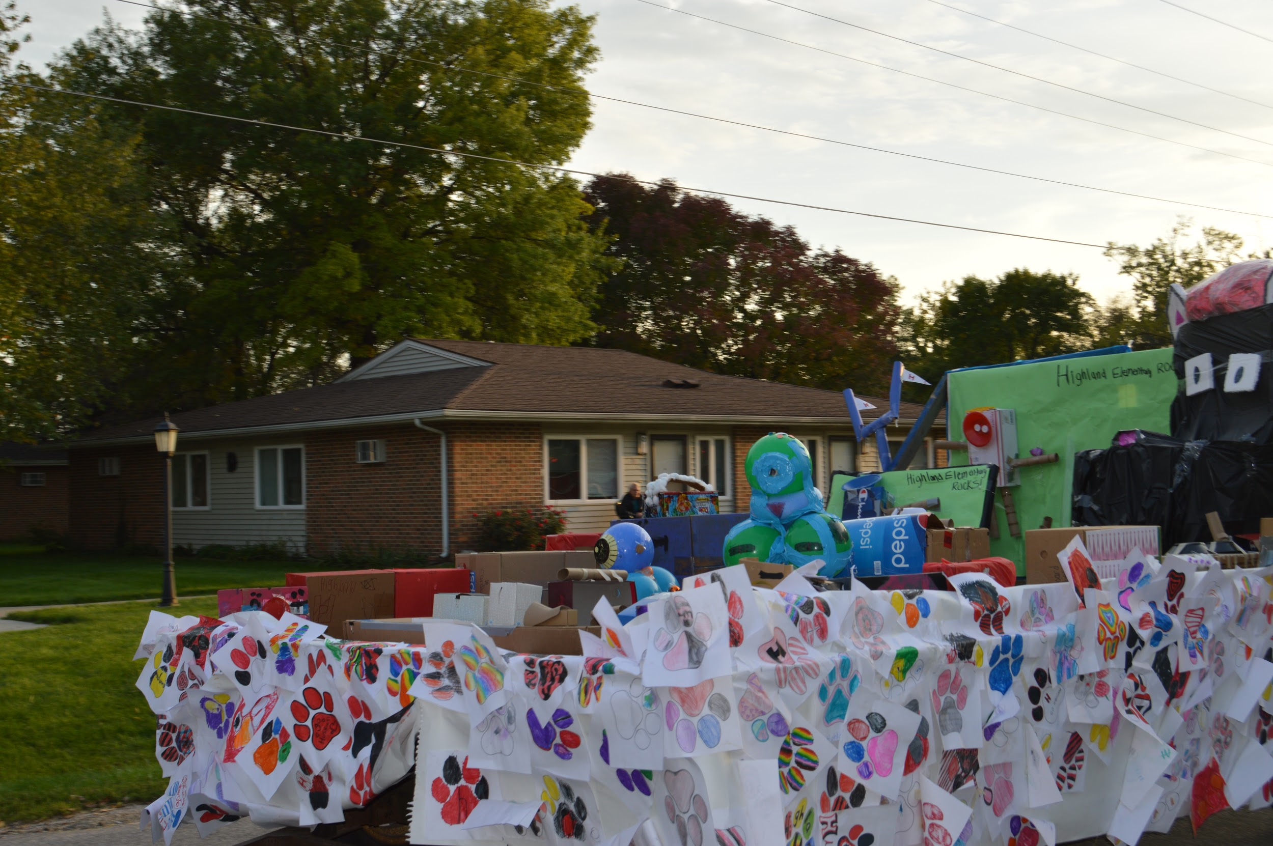 | Another exciting thing we noticed were the painting of the bathroom stalls. Each stall has a positive message painted on the door! This act of kindness is appreciated by all the students and staff here at Highland Elementary. We would like to send a shout out to all the staff members and parents who put their artistic mark on this and making it happen. It is a constant reminder that we are the best we can be and we CAN make a difference in this world.
Look for a flier to come home soon about our first FUNDRAISER! This is going to help with the cost of the Yearbook as well as any other cost the student council may have. | 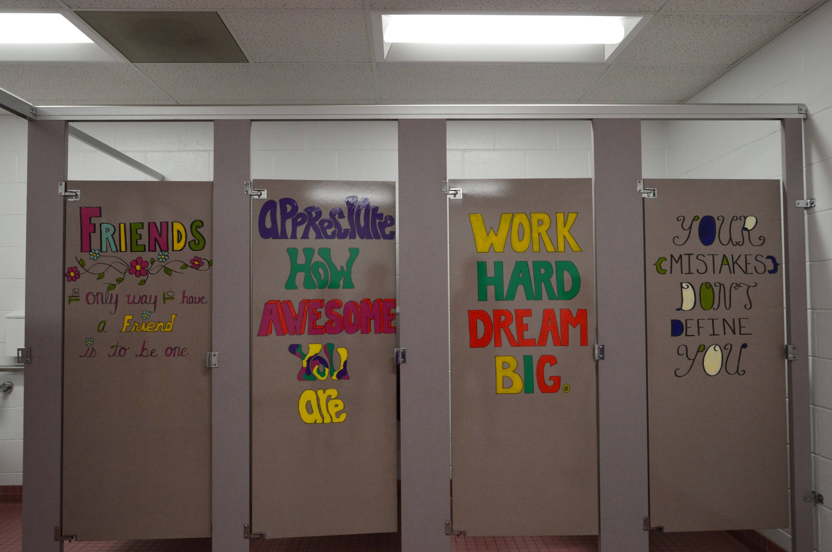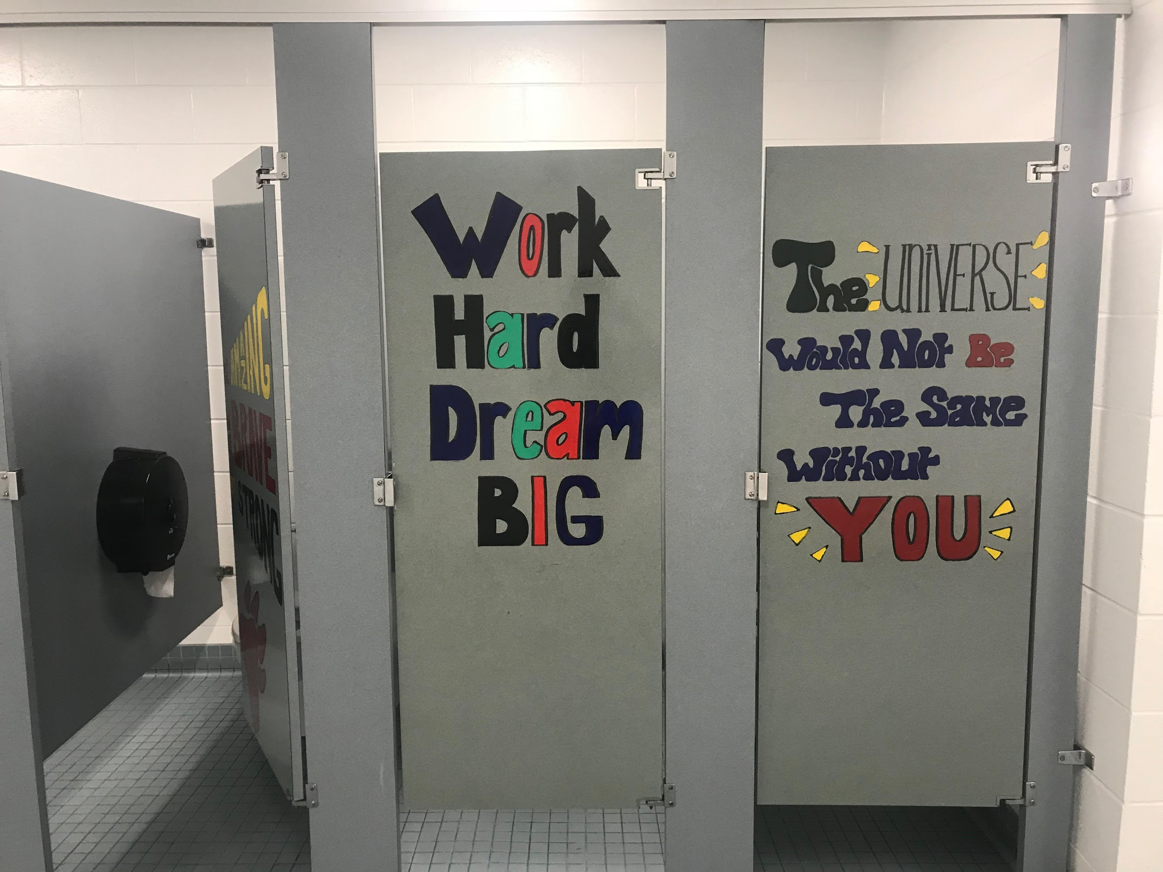

This weeks “STAR STUDENTS” are:
Brena Hazelett  Brena is the youngest in her family. Her favorite movie is Miracle Season. When she graduates she would like to be a nurse for babies. In Brenas free time she likes to hang out with her friends and family and eat chicken drumsticks. Something you may not know about Brenna is she is good at art and when she was born she could not breathe. | Brayden Zywiec  Brayden is really good at Math. His favorite book is Percy Jackson #1 and he loves to eat cheese soup. When he isn’t at school having fun at recess he enjoys playing video games. Something you may not know about Bryden is he once fell on a barbwire fence. | Bryce Hazelett  Bryce is an avid sportsman. He loves PE, the movie Rookie of The Year and playing baseball is his free time. When Bryce grows up he would love to play baseball in the Major Leagues. He likes the band Florida Georgia Line, eating pizza, and in school he enjoys Math. You may not know this but Bryce is not a big fan of storms.
Emily Herrig  Emily is the youngest of three girls. She has two big dogs and loves hot wings. Emily is afraid of snakes and spiders. Her favorite book is The Hatchet and loves listening to music especially Sweet Caroline. Just like The Huskies her favorite color is RED! | Adisyn Prottsman  Adisyn Jo also known as Adi is the oldest of three. She like Social Studies, reading the book My Weird School and playing softball. When she grows up she would like to be a hairstylist. You may not know this about Adi but she can ride her bike without any hands! | Hailey Plank  Meet Hailey, the youngest of two, who in her free time love to play with her dog and cat. Her favorite book is Whatever After, favorite movie is The Greatest Showman and loves to listen to Meghan Trainor. At school she like Social Studies. I bet you don’t know this but, Hailey wants to go to school to be a hairstylist. Just ask her what her favorite thing to do with her hair is when you see her next!
Keaton VanSchoyck  Keaton Paul has a dog and raises chicken. He has an older brother and a younger sister. Dragons Love Tacos is his favorite book, but he likes to eat dessert pizza! His favorite color is gold. Whether he is in school or out of school Keaton enjoys reading. When he grows up he wants to be a Television Host. Something he doesn’t like is bad storms. | Siena Stanerson  Siena is the oldest of three girls. She enjoys school especially Math and doing crafts. With her love of the soundtrack The Greatest Showman she would like to be a singer when she grows up! Some more of Siena’s favorites are the book Wonder, the color pink and eating Mac and cheese. I bet you didn’t know that Siena moved to Iowa when she was two from St. Louis. You will have to ask her but I bet she is a Cardinals fan! | Emma Smart  Emma may be an only child, but she has a dog and a cat! She loves reading in school and in her free time. One of her favorites is Harry Potter! More of Emma’s favorites are the color teal, baking then testing out her yummy work by eating those sweet treats. Something you may not know about Emma is she loves to show pigs!

Erika Thomann
Erika is one of five kids and she has a twin brother. She enjoys the book Ghost girl, the movie Miracle Season, eating tacos, the color green and listening to country music. At school she enjoys recess and PE. At home she likes to watch tv. Erika wants to be a Vet Tech when she grows up, but is afraid of snakes. You may not know this about Erika, but she enjoys writing!

