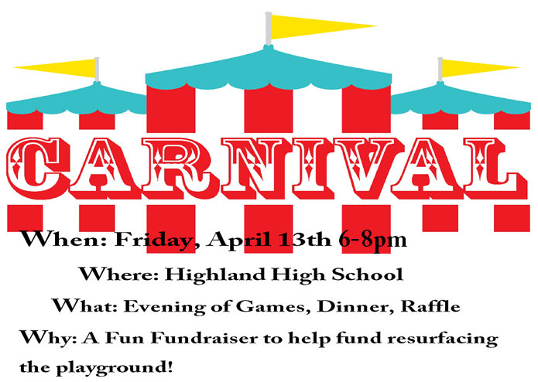
Each class will prepare a class room basket for the Carnival Basket Raffle.
Themes are as follows:
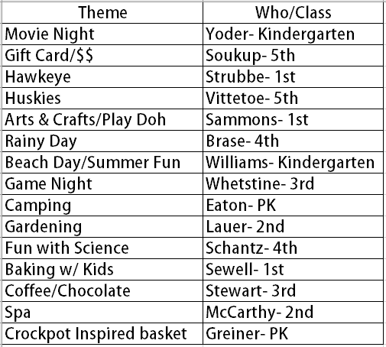
Please have items to your teacher by March 19th!

