How To Talk With Kids About Terrible Things
- Facebook
- Twitter
- Flipboard
- Email
February 18, 20186:11 AM ET
Cory Turner
Twitter
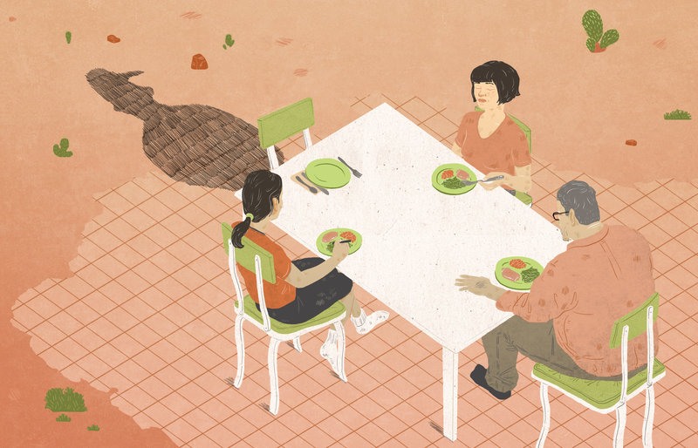
Enlarge this image
LA Johnson/NPR

LA Johnson/NPR
For the more than 3,000 students at Marjory Stoneman Douglas High School, Wednesday's mass shooting was terrifying and life-changing. But what of the tens of millions of other children, in schools across the country, who have since heard about what happened and now struggle with their own feelings of fear, confusion and uncertainty?
For their parents and teachers, we've put together a quick primer with help from the National Association of School Psychologists and Melissa Reeves, a former NASP president and co-author of its PREPaRE School Crisis Prevention and Intervention curriculum.
Tune in
First, pay attention. Not just to what kids say, but what they do.
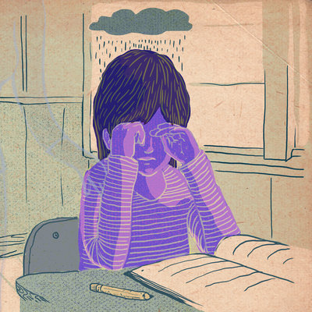

NPR Ed

Grief In The Classroom: 'Saying Nothing Says A Lot'
"Watch for clues that [children] may want to talk, such as hovering around while you do the dishes or yard work," NASP recommends. "Some children prefer writing, playing music, or doing an art project as an outlet."
For younger children, drawing or imaginative play can help them give voice to their fear, anxiety and other difficult feelings.
When the conversation starts ...
Emphasize: You are safe
"The cardinal rule when talking about this kind of tragedy with children of all ages," Reeves says, "is for adults to reinforce the safety efforts that their schools and the adults in their lives are already taking to keep them safe."
Be specific, reminding them that's why the school doors are locked all day and why they practice emergency lockdown drills.
Also, remind children and teens that, in spite of the headlines, schools are still the safest place for them to be. Unfortunately, Reeves says, this important message is undermined by relentless media coverage; disturbing news and images of the Parkland shooting have been ubiquitous (more on this later).
Article continues after sponsorship
In its guidance, NASP offers this reminder: "Although there is no absolute guarantee that something bad will never happen, it is important to understand the difference between the possibility of something happening and probability that it will affect you (our school community)."
Let their questions be your guide
This is especially true for young children, who may know very little about what actually happened but heard something on TV or glimpsed a disturbing photograph online or in the newspaper.
"If students are saying, 'We heard something really bad happened at a school yesterday,' keep it general," Reeves advises.
Ask, "What did you hear?"
If the child says, "Some kids got really hurt," you can respond reassuringly but without unnecessary detail. Reeves suggests something like this:
" 'Yes, some kids did get hurt, and here's what the adults are doing at your school to make sure you stay safe.' "
For older kids who may know more details about the shooting — and that many students were killed — it's important, Reeves says, to acknowledge the tragedy and not make promises that you, as a parent or teacher, can't keep.
Instead of saying, "I'm positive nothing bad will ever happen at your school," walk them through the concrete steps being taken to ensure their safety.
Control, control, control
A school shooting anywhere can make students everywhere feel powerless, and that sense of helplessness can feed anxiety.
"What you want to do is give them a sense of control," Reeves says.
For young students, NASP recommends emphasizing simple examples of adult-led school safety like "exterior doors being locked, child monitoring efforts on the playground, and emergency drills practiced during the school day."
These things should not only help a child feel safer but also give her a sense of agency.
For older students, that list expands to include reporting strangers on campus as well as potential threats made by classmates or members of the immediate community.
Social media
One important risk for parents and teachers to keep in mind comes from teens' exposure to social media. Disturbing photos and videos taken during the Parkland shooting quickly began circulating.
For some teens, Reeves says, engaging with this kind of material can cause what's known as secondary trauma. "Parents must monitor their kids' social media use and give them permission to step away."
As an example, Reeves offers the story of her own daughter who, she says, had been texting back and forth with friends after the school shooting at Sandy Hook Elementary in Newtown, Conn. In that case, they weren't sharing graphic images or news reports — just seemingly harmless messages of grief and support.
But, Reeves says, with every new message coming in, she could sense her daughter's anxiety level rising. And, she says, her daughter resisted turning off her phone for fear that her friends would think she didn't care.
"I find many students, when you explain to them that this can be traumatizing and give them permission to step away, they're very relieved," Reeves says.
Technology has eroded teens' boundaries, Reeves believes, making them want to share everything over social media. Her message to them is clear:
"This is not healthy. This is hurting you, and this could be hurting your friends."
Note: Teachers and parents, how have you navigated difficult conversations about tragedies like the Parkland school shooting? We'd like to hear from you. Send us an email to npred@npr.org.

