Taco Supper 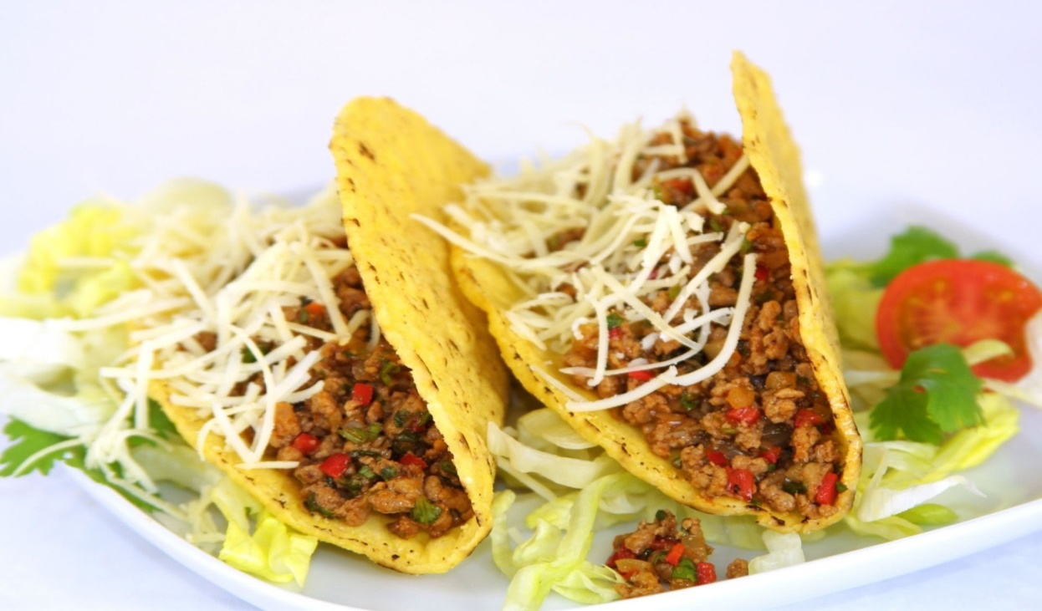
Friday - January 4th, 2019
(Lone Tree versus Highland Basketball games)
5 – 8 PM
$5.00 Meal
2 tacos, dessert, and drink
(Presented by Lone Tree Post Prom Committee)

